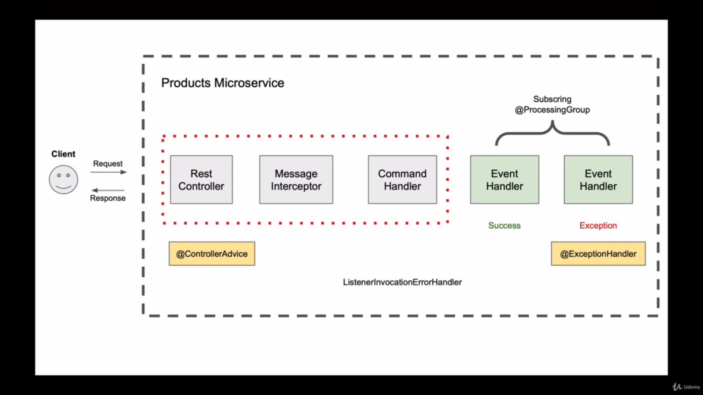

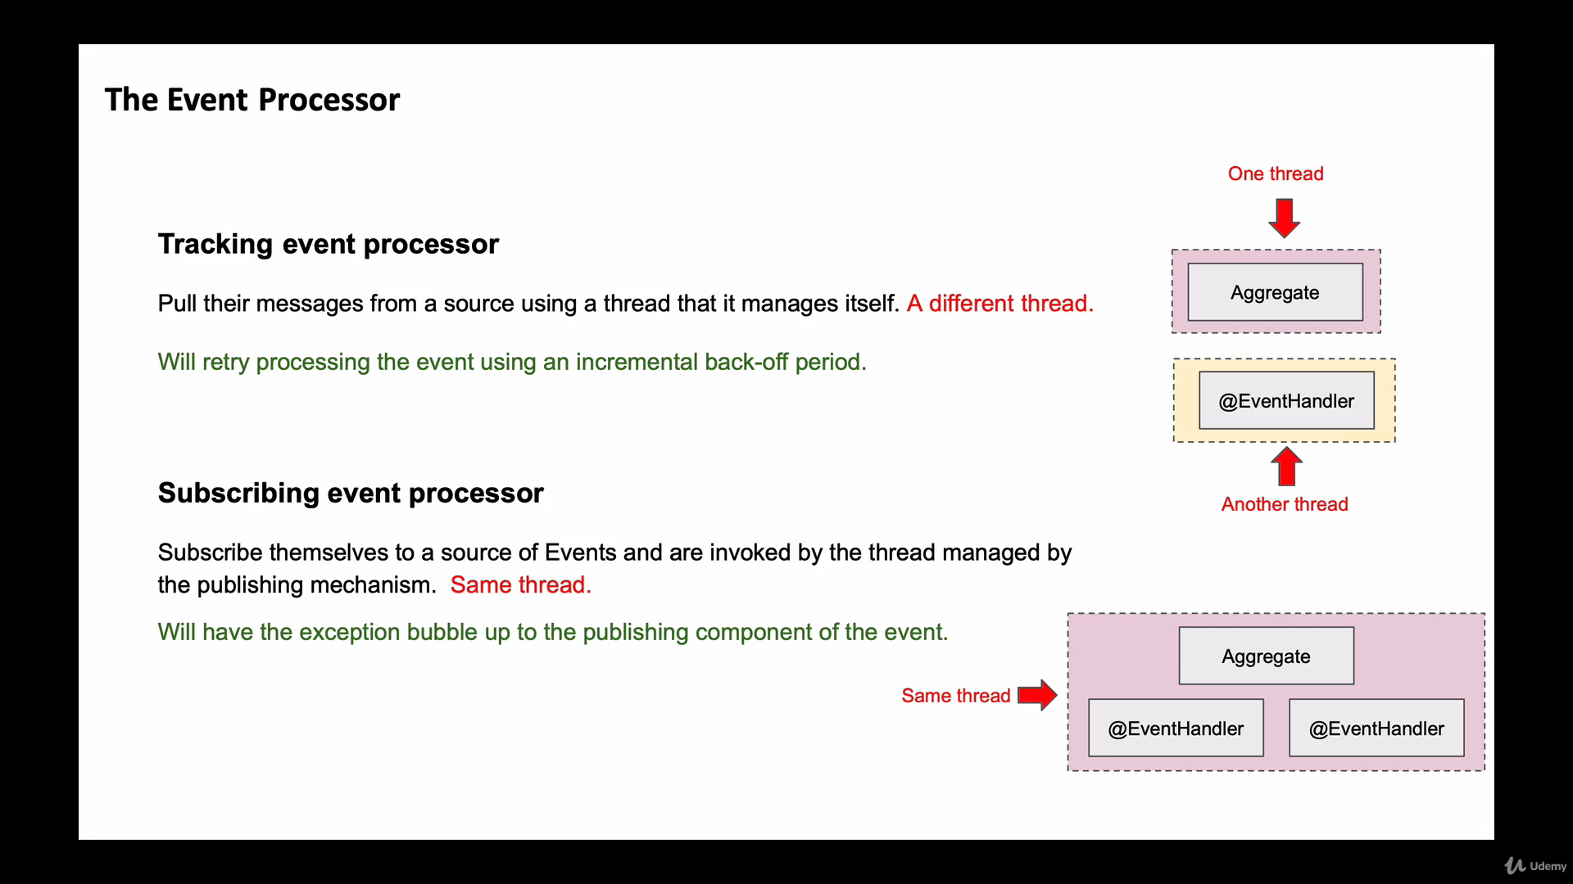

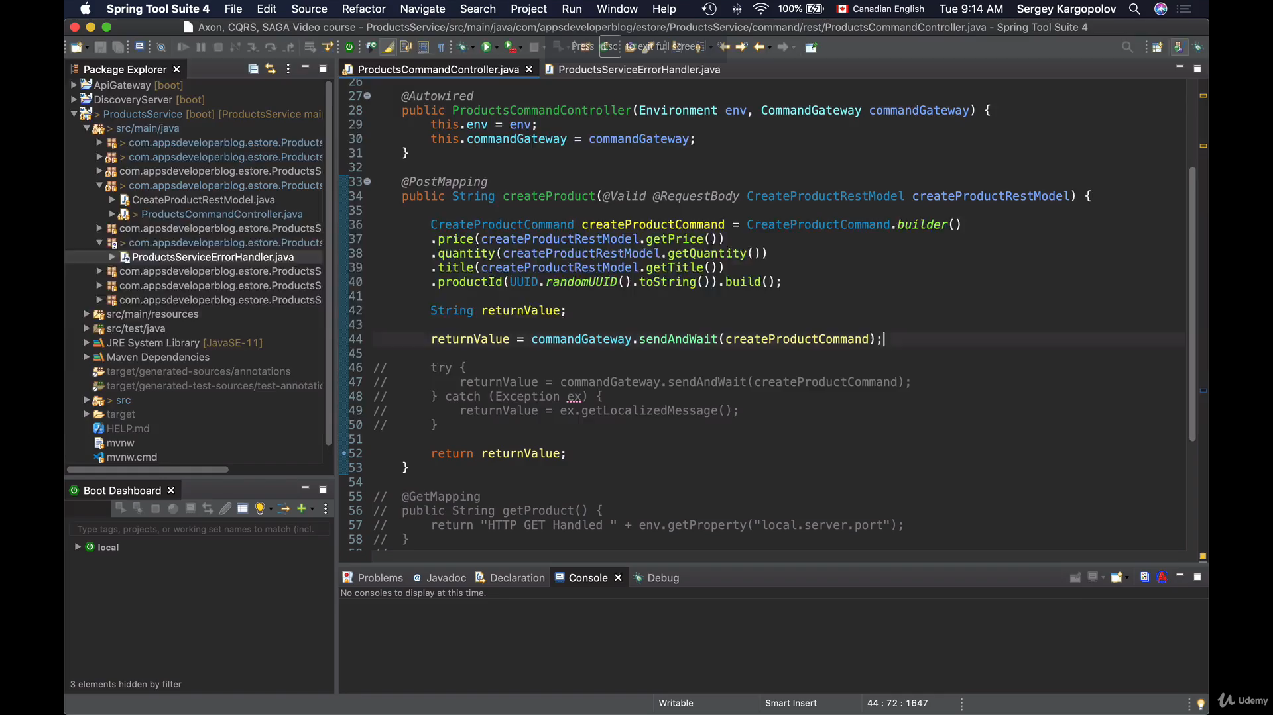

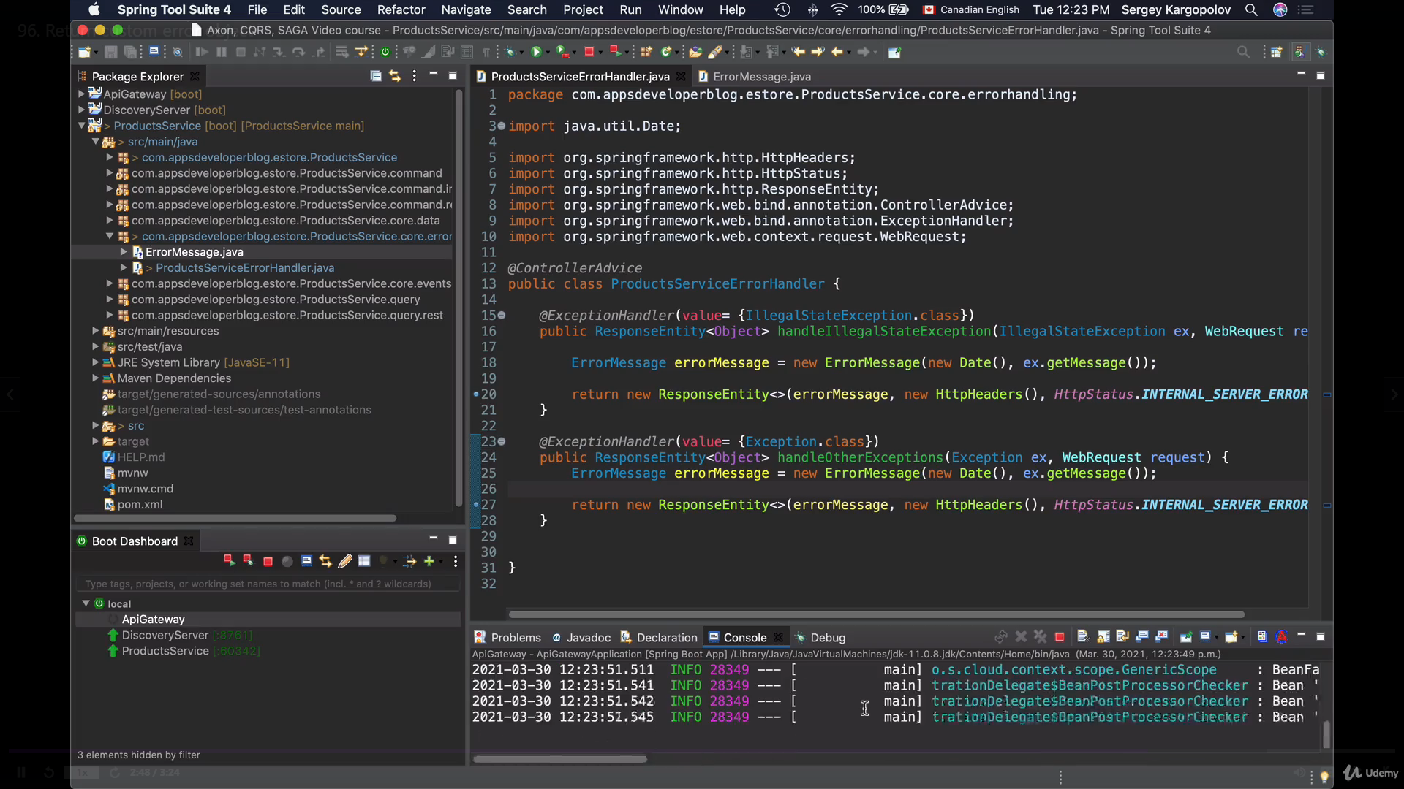

**Use of CommandExecutionException** : If we get any exception in method annotated with @CommandHandler then throws the CommandExecutionException exception and Method annotated with @EventSourcingHandler will not be called although AggregateLifeCycle.apply() method will be called prior because Axon framework does not called straightway. So we need to configure this exception in @ControllerAdvice.

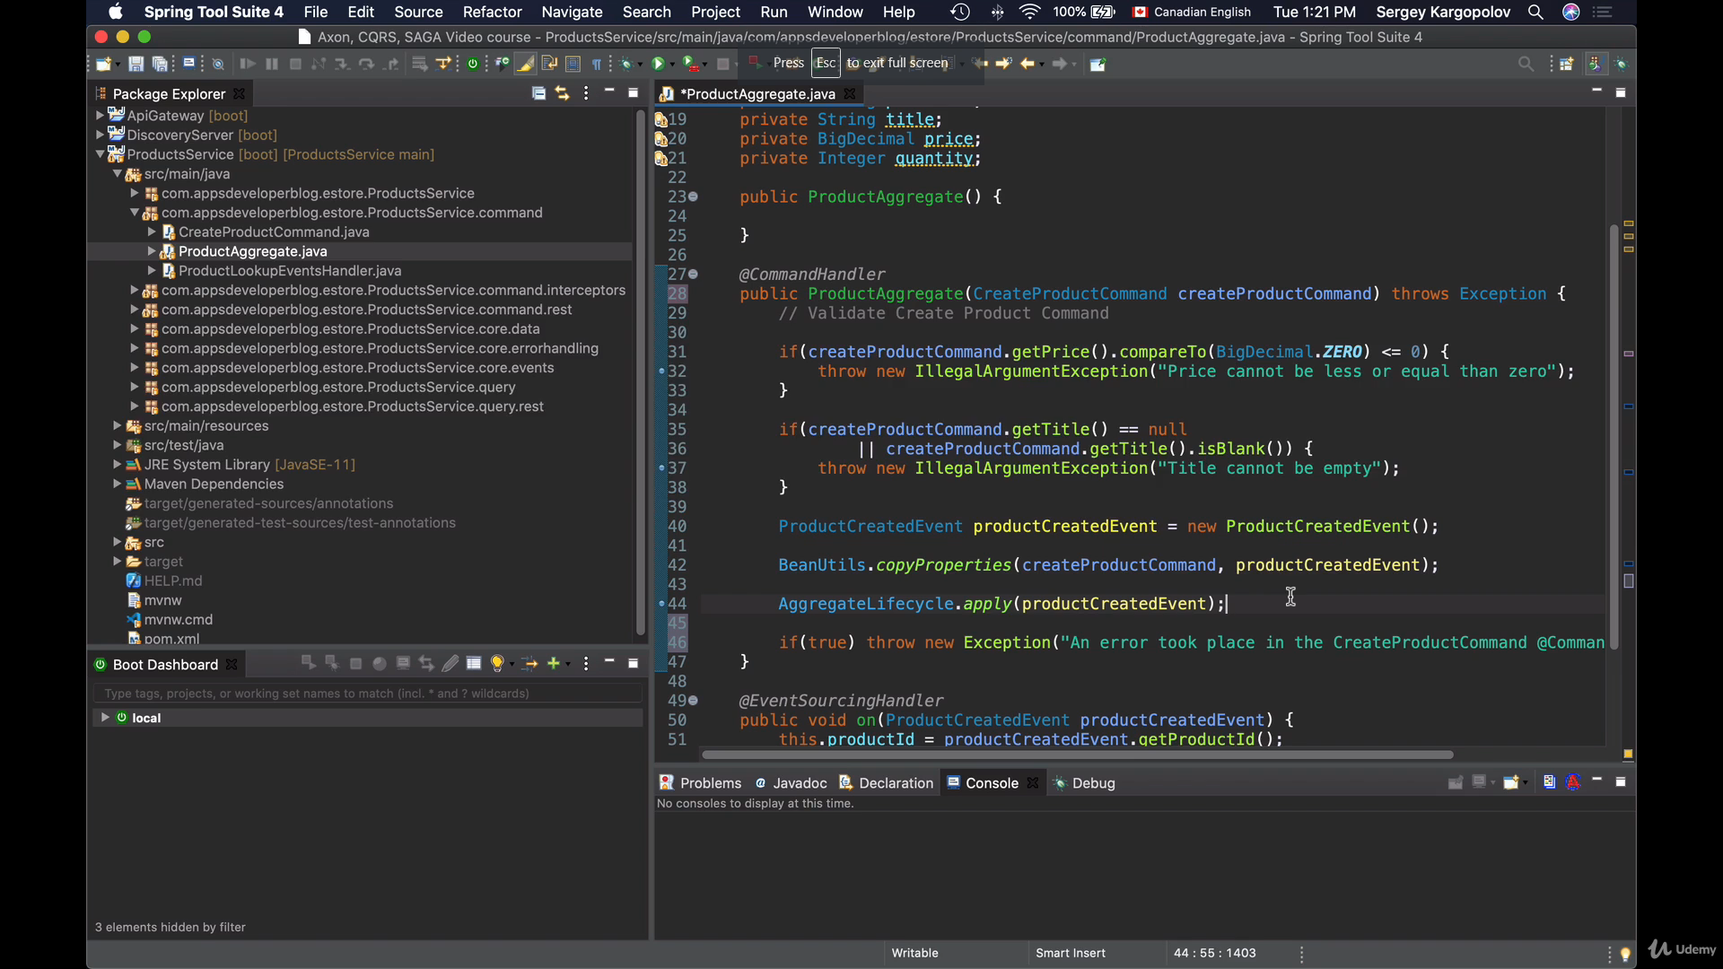

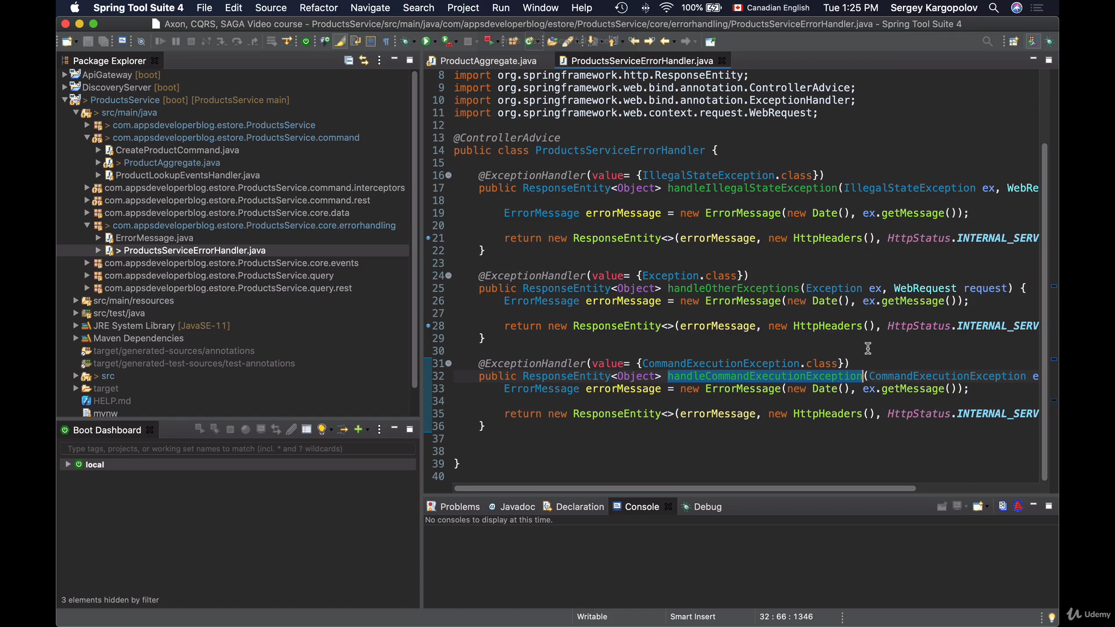

* Now handling @ExceptionHandler of Axon Framework and ListenerInvocationErrrorHandler at consumer side : EventHandler Side

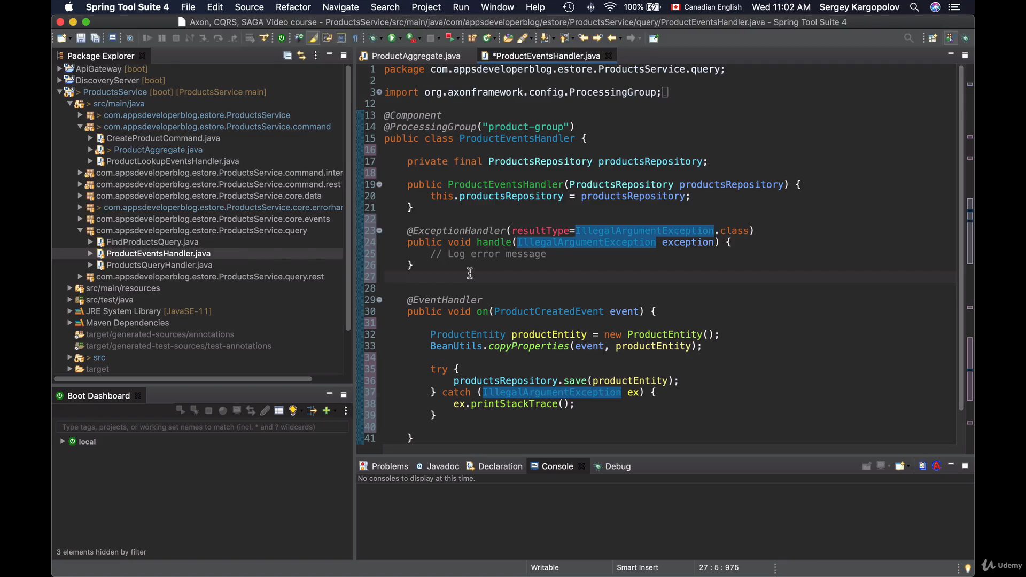

ListenerInvocationErrrorHandler will be responsible to propagate the exception raised by the EventHandler side to CommandHandler Side.

Now in ProductEventHandler class, rethrowing the exception

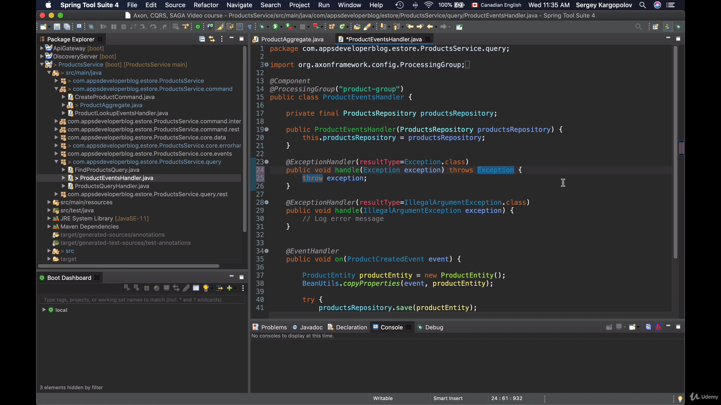

ProductServiceEventsErrorHandler

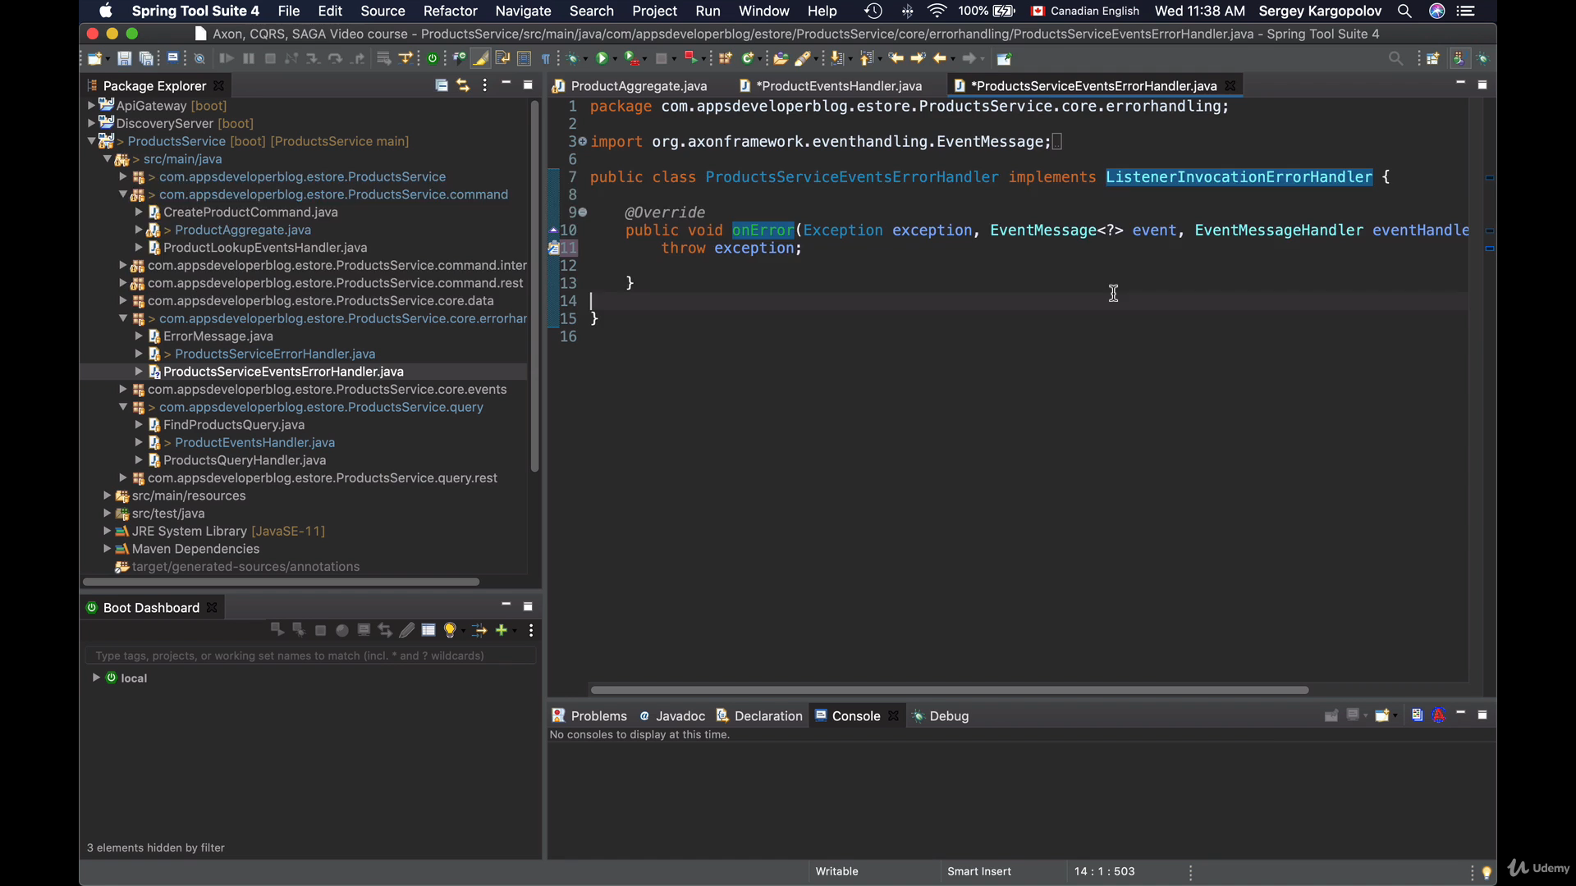

To register the ProductServiceEventsErrorHandler which implements ListenerInvocationErrrorHandler

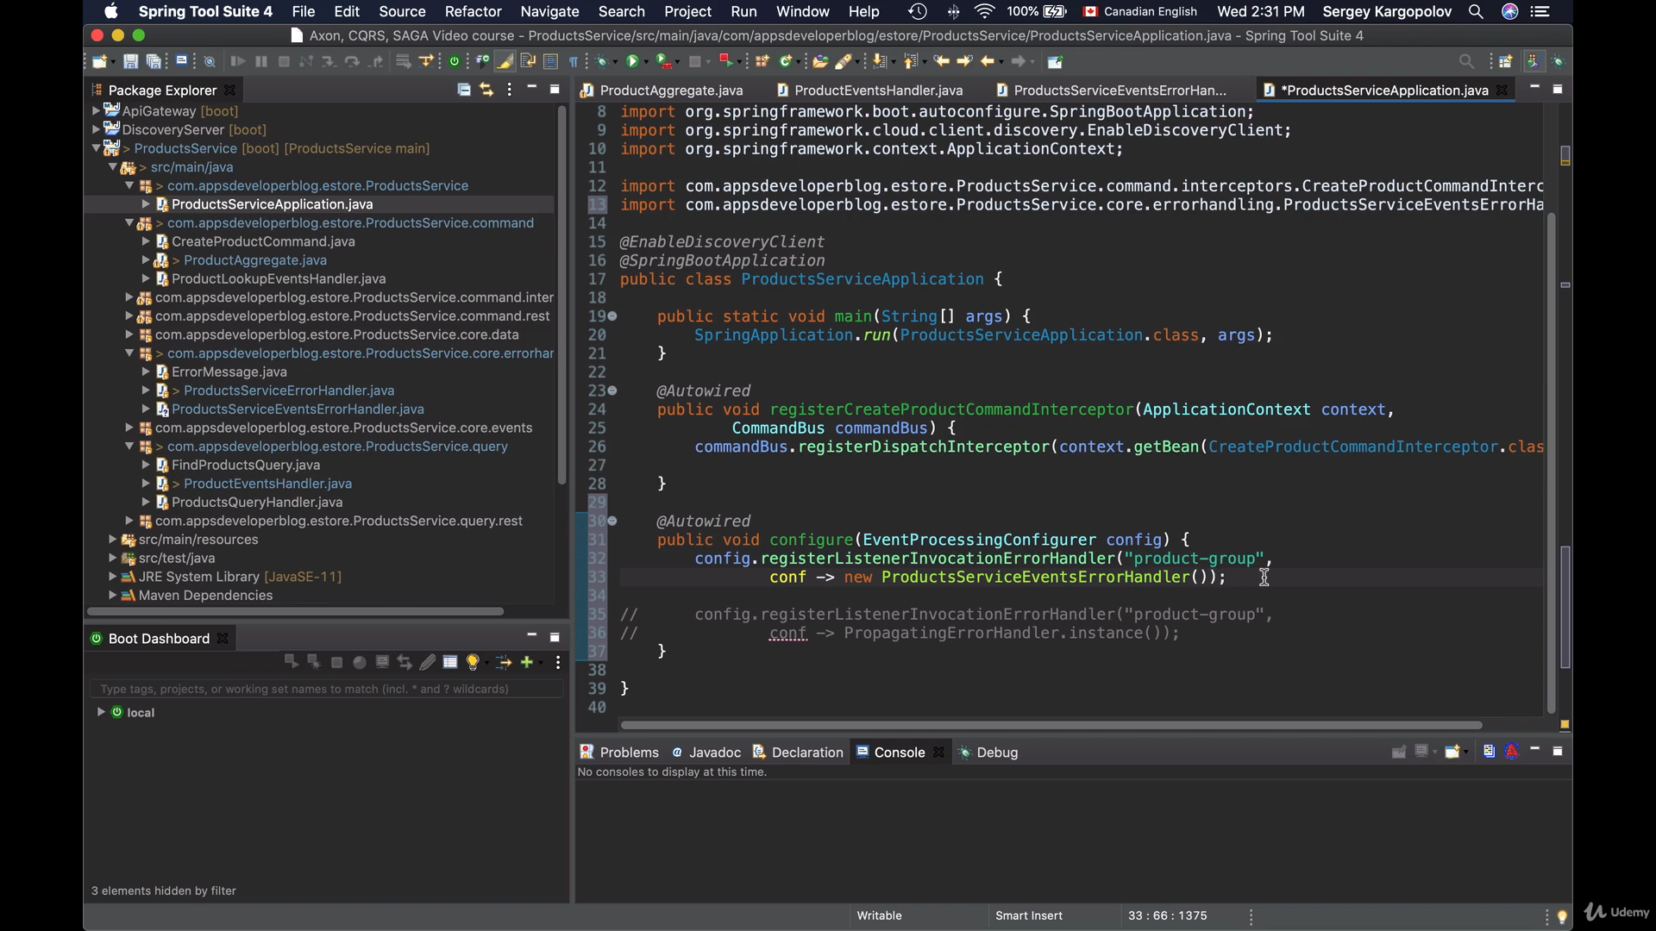

How it works: Now we are explicitly throwing the exception in the method annotated with @EventHandler

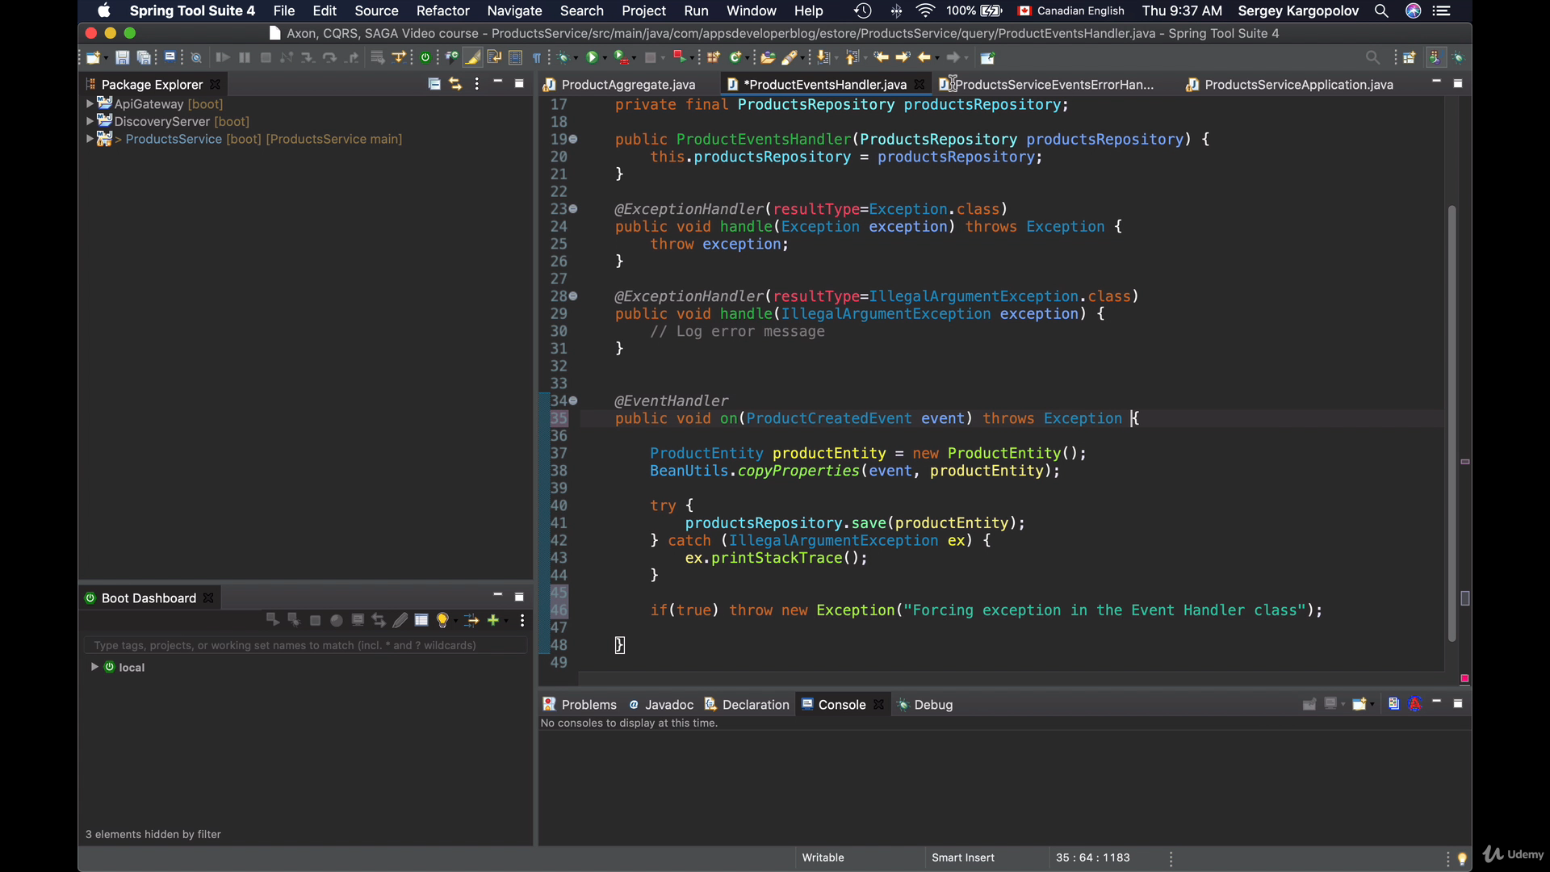

1. First Exception throws from event handler, means no commit.
2. There is exceptionhandler in this class, debugger will go there.
3. After that it will go to the ProductServiceEventsErrorHandler which implements ListenerInvocationErrrorHandler, where we will rethrow the exception.
4. Finally this exception will propagate to ExceptionHandler method @ControllerAdvice at CommandHandler Side.